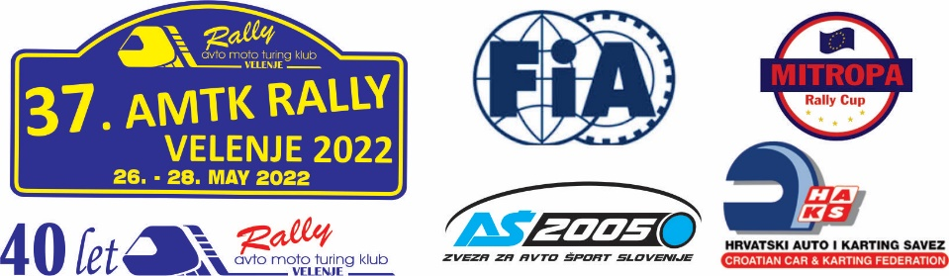
Štarta številka / Competition No.

V primeru nesreče obvestite spodaj navedeno osebo, ki jo obenem pooblaščam za urejanje formalnosti:
In case of emergency/accident contact person below, which is also authorized to regulate the formalities:

Priimek / Surname
Ime / Name
Datum rojstva / Date of birth
Tel. Številka / Phone number

Spodaj podpisani pooblaščam vodstvo dirke 37. AMTK Rally Velenje 2022, da od zdravstvenih ustanov pridobijo podatke o poškodbah.
The undersigned hereby authorize The Headquarters of 37. AMTK Rally Velenje 2022, to obtain medical informations on injuries from Medical Institutions.

Priimek / Surname
Ime / Name
Društvo / Club

_____________________________ ______________________________
datum / data podpis / signature

